Through the Newton Rotary Foundation, the Rotary Club of Newton awards six scholarships each year to graduating high school seniors. The nominees are submitted by teachers and guidance counselors, and then a team of school personnel and club members interview the candidates and select the final recipients.
Three scholarships are awarded to students who have excelled in the Career & Technical Education programs that are housed at Newton North High School and attended by students from both high schools. They include:

- Automotive Technology
- Carpentry
- Culinary Arts
- Design & Visual Communications
- Drafting
- Early Education & Care
- Graphic Communications
- TV Media Arts

These scholarships are named the:
- “Martinson Bell & Flag Award”, given in honor of Bert Martinson who was a longtime club member until his death in 2017 at 104 years old. We believe he was the oldest living Rotarian at the time of his passing.
- “William Rockwell Memorial Award”. Bill was a long time, dedicated, and much beloved member of the Rotary Club of Newton. Because Bill was a get-you-hands-dirty kind of guy, he was dedicated to the technical arts program and the students who won our Tech Scholarships.
- “The President’s Award”, given in honor of the person who is currently President of the Rotary Club of Newton. Ron Faccenda is the President until June 2021.

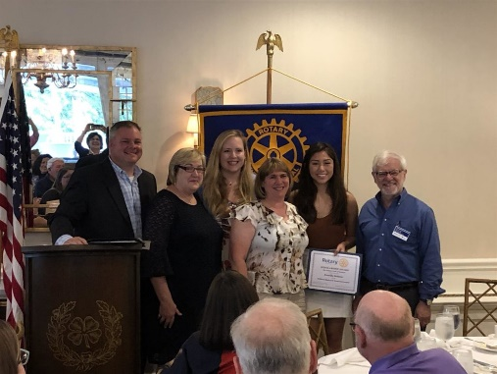
These scholarships are awarded at the club’s yearly “Scholarships Luncheon” held at the Braeburn Country Club each June. It is routinely one of the most energetic and enjoyable meetings of the year. The most recent recipients of the Rotary Career & Technical Education programs were Kamilla Salazar, Benjamin Gobler, and Jonathan Rosenstrach. Kamilla is pictured with Club President Ron Faccenda, two of the culinary arts teachers, and club member, luncheon “Master of Ceremonies”, and Director of the John M. Barry Boys & Girls Club, Dave Sellers.

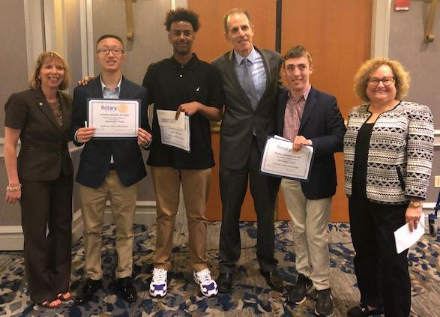
Newton Rotary also awards three scholarships for college-bound seniors which are named in honor of long-time Rotarian Tony Bibbo. Tony was an active and influential member of the club, and was dearly loved by our own members, the greater Newton community, and Rotarians around the region.
One scholarship goes to a graduating senior from Newton South, another to a Metco student, and the third to a Newton South senior.
These scholarships are awarded in May at the Mayor’s Community Breakfast. With all of Newton’s “movers & shakers” in attendance, it’s a pleasure to introduce them to each year’s scholarship winners. The most recent recipients of the Anthony A. Bibbo Scholarships were Aaron Xu, Abel Yohannes and Alexander Yood, pictured above (l-r) with Rotarian Marie Presti, Superintendent of Schools David Fleishman, and Rotarian Susan Paley.
Donations provided through the club’s new Boston Marathon runner program will enable the scholarship grants to be increased and allow the organization’s general fundraising to be directed to other vital Rotary programs such as the Rotary Youth Leadership Program, the Community Grants program, and the Newton Summer Reading Program. Rotary also supports community service clubs
The Newton Rotary Foundation is a 501(c)(3) organization. The Foundations EIN is 04-3581396.

